Where’s Waldo

There are various ways and techniques when it comes to template matching. In my first assignment, I was given the task in finding Waldo within a collection of two images. The goal was to get familiar with the programming language Python, and OpenCV, while trying to find Waldo.

Template matching is simply a way for finding areas between two images that match one another. In OpenCV there are six different methods to tackling template matching; cross coefficient (CCOEFF), cross coefficient normalized (CCOEFF_NORMED), cross correlation (CCORR), cross correlation normalized (CCORR_NORMED), square difference (SQDIFF), and square difference normalized (SQDIFF_NORMED).

Source Image #1

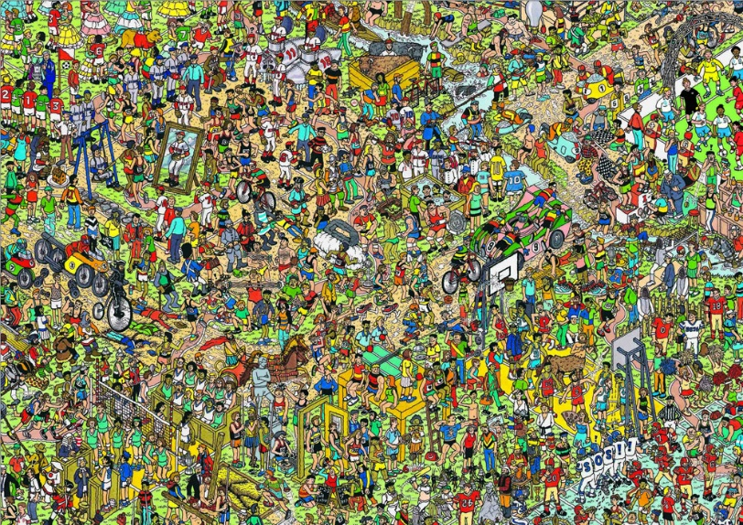

Template Image #1



CCOEFF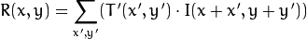

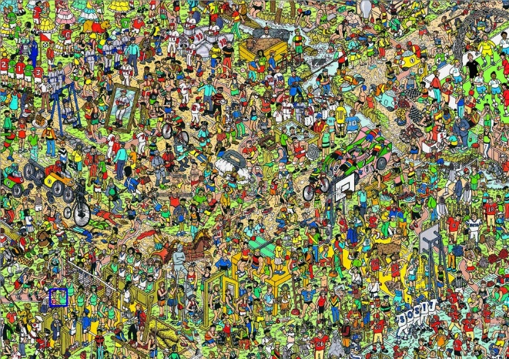

COEFF_NORMED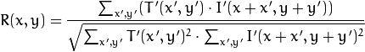



CCORR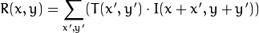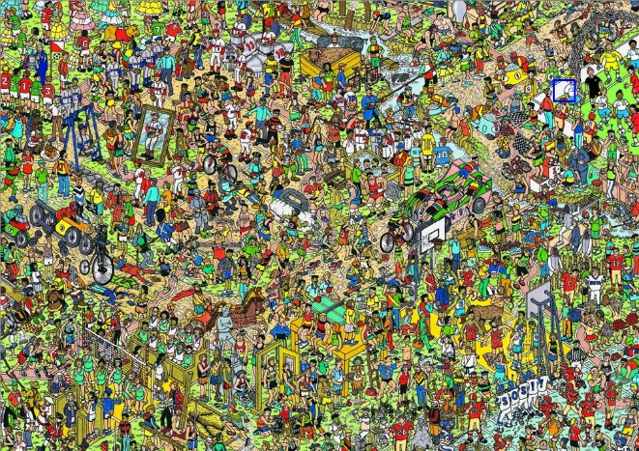

CCORR_NORMED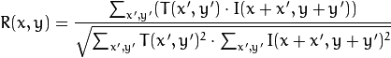

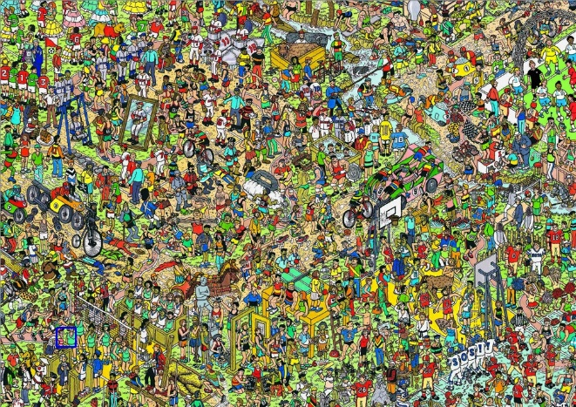

SQDIFF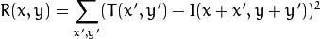



SQDIFF_NORMED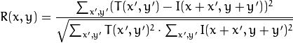



Source Image #2

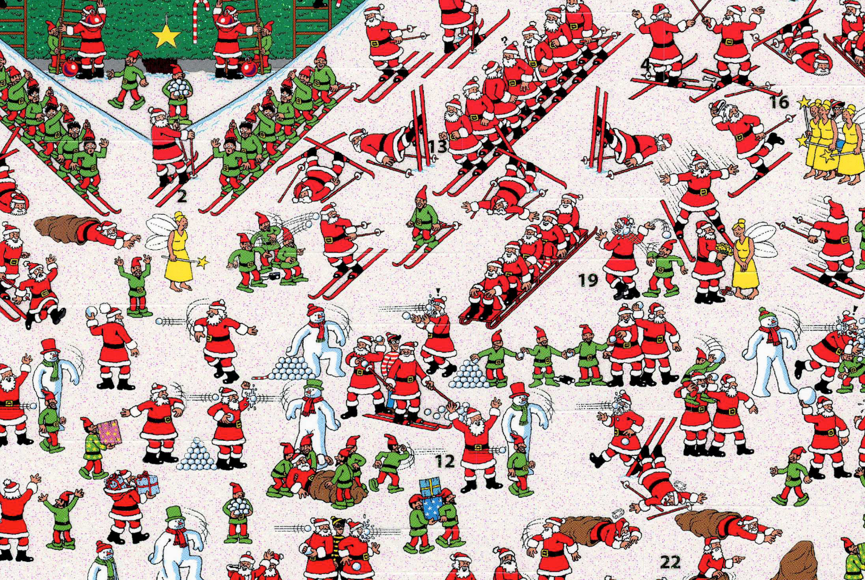

Template Image #2

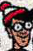

CCOEFF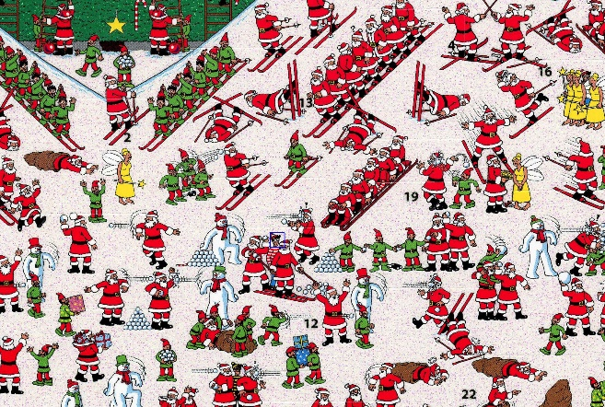

COEFF_NORMEDCCORR

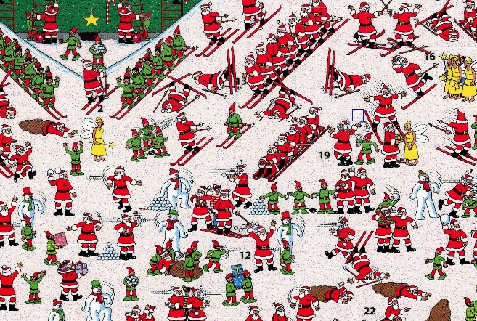

CCORR_NORMED 

SQDIFF



SQDIFF_NORMED



**Conclusion**

Although I am very familiar with the Python language, I had never worked with OpenCV before. From this assignment, it looked to be a very simple and easy to use tool. As we can see from the results, all but cross correlation (CCORR) gave the correct result for finding where Waldo is. For both images, CCORR selected an area that is predominantly white. Even though we only tested it on two examples, based on these results, I would avoid using cross correlation for when it came to finding Waldo.